CSA6303 - THREAT INTELLIGENCE AND NETWORK SECUR
Assessment Tool 1: CONCEPT MAPPING
Faculty : Dr.V.Parthipan SLOT A

Topics: Network Security Fundamentals | Security Goals (CIA Triad) | Types of Network Threats |Introduction to Threat Intelligence Types of Threat Intelligence (Strategic, Tactical, perational) — Threat Intelligence Lifecycle — Applications in IT Industry
CO1: Interpret security principles, network threats, and the role of threat intelligence in cybersecurity.

Total: 50
Student Name : EPURU DHARMIK REDDY Register number: 192365038

Code of Conduct:

I EPURU DHARMIK REDDY / 192365038 certify that this submission is my original work and that I have adhered to the guidelines specified for this assessment. I understand that any violation of academic integrity rules will result in disciplinary action.

E.Dharmik Reddy
Signature of the student

Question 5
Question: Construct a concept map explaining the concept of Threat Intelligence and its role in modern network security. Relate threat actors, indicators, vulnerabilities, attack patterns, threat information, analysis, and actionable intelligence to demonstrate how Threat Intelligence helps organizations anticipate and respond to network threats.
Bloom's Level: Analyze (L4)
1. Approach
Threat Intelligence is placed at the centre-top of the map. Beneath it are the four "knowledge elements" it describes (threat actors, attack patterns, vulnerabilities and indicators). These elements feed threat information, which passes through analysis to become actionable intelligence. Actionable intelligence then branches into proactive (anticipate) and reactive (respond) uses, ending in better security outcomes.
2. Key Concepts Used in the Map
Concept | Meaning | Role in the map
Threat Intelligence | Evidence-based knowledge about existing or emerging threats, including context, mechanisms, indicators and advice, used to inform decisions. | Central concept; strengthens network security.
Threat Actors | Cybercriminals, nation-states, hacktivists and insiders who carry out attacks. | Answers "who" and "why" (motives, capabilities, targets).
Attack Patterns (TTPs) | Repeatable tactics, techniques and procedures such as phishing, ransomware, lateral movement and DDoS. | Answers "how"; used to predict future attacks.
Vulnerabilities | Weaknesses in software, configuration or people that can be exploited. | Answers "where"; links threats to the organisation's exposure.
Indicators (IoCs) | Observable artefacts such as malicious IPs, domains, file hashes, URLs and abnormal log behaviour. | Answers "what to look for"; enables detection.
Threat Information | Raw, unevaluated data from logs, feeds, OSINT, dark-web sources and sensors. | Input collected from all four elements.
Analysis | Validating, correlating and enriching data, then judging confidence and relevance to the organisation. | Converts data into intelligence.
Actionable Intelligence | Timely, accurate, prioritised intelligence tied to the organisation's own assets. | Directly usable by defenders and decision-makers.
Anticipate / Respond | Proactive use (hunting, forecasting, patching) and reactive use (blocking, containing, recovering). | The two ways intelligence improves security.
Concept Map – Threat Intelligence and Its Role in Modern Network Security
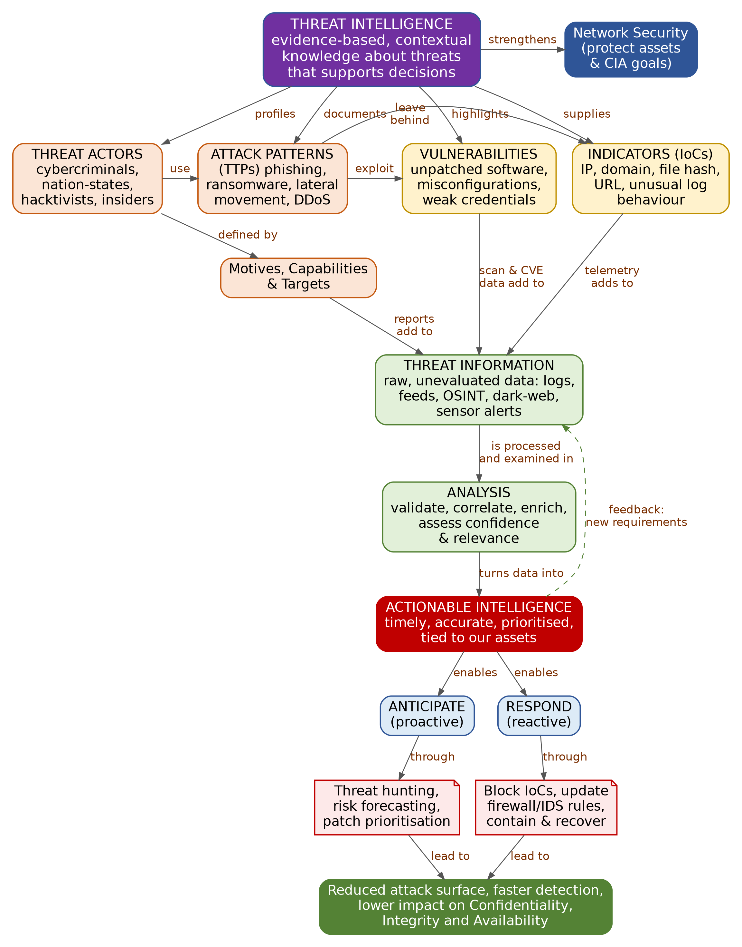
3. Explanation of the Relationships
From concept | Linking phrase | To concept / explanation
Threat Intelligence | strengthens | Network Security: adds outside-in knowledge to existing controls.
Threat Intelligence | profiles / documents / highlights / supplies | Threat Actors, Attack Patterns, Vulnerabilities and Indicators: the four elements it describes.
Threat Actors | use | Attack Patterns: each actor has preferred techniques that help attribute and predict attacks.
Threat Actors | defined by | Motives, Capabilities & Targets: explains which organisations are likely to be attacked.
Attack Patterns | exploit | Vulnerabilities: techniques succeed only where weaknesses exist.
Attack Patterns | leave behind | Indicators: every technique produces observable traces.
Vulnerabilities / Indicators / Motives | add to | Threat Information: scan data, telemetry and reports are collected as raw inputs.
Threat Information | is processed and examined in | Analysis: filtering, correlation, enrichment and confidence scoring.
Analysis | turns data into | Actionable Intelligence: relevant, prioritised and timely.
Actionable Intelligence | enables | Anticipate (hunting, forecasting, patch prioritisation) and Respond (block IoCs, update rules, contain, recover).
Anticipate / Respond | lead to | Reduced attack surface, faster detection and lower impact on Confidentiality, Integrity and Availability.
Actionable Intelligence | feedback: new requirements | Threat Information: lessons from use create new collection needs (dashed loop).
4. Analysis
Understanding the adversary. Actors, attack patterns, vulnerabilities and indicators answer who, how, where and what to look for. Individually they are facts; linked together they form a picture of a threat: an actor with a motive uses a technique against a weakness and leaves an indicator.
Information is not intelligence. The same facts arrive as an unfiltered stream of alerts and feeds (threat information). Without analysis, the volume overwhelms analysts and produces false positives. Analysis supplies context, validation and relevance so that only items that matter to the organisation's assets are acted on.
Anticipating threats. Knowing an actor's favoured techniques and the vulnerabilities currently being exploited allows an organisation to patch the right systems first, harden exposed services and hunt for early signs of compromise before damage occurs.
Responding to threats. When an attack is already underway, indicators allow rapid blocking and scoping, while attack-pattern knowledge predicts the attacker's next step so responders can contain and recover faster. In both cases the CIA goals are better protected.
5. Conclusion
Threat Intelligence turns scattered data about actors, attack patterns, vulnerabilities and indicators into analysed, actionable knowledge. By supporting both anticipation and response, it moves network security from a purely reactive posture to an informed, proactive one, and its feedback loop keeps the intelligence aligned with the organisation's changing risks.

Question 6
Question: Develop a comparative concept map of Strategic, Tactical, and Operational Threat Intelligence. Connect each type with its purpose, target audience, time horizon, information requirements, decision-making process, and appropriate network-security use cases, and analyze how the three intelligence types complement one another.
Bloom's Level: Evaluate (L5)
1. Approach
The map has one column for each intelligence type, arranged from long-term (left) to short-term (right). Each column is a chain of six labelled links: purpose, audience, time horizon, information needs, decision process and network-security use cases. Red arrows between the three type boxes show how the types feed and complement one another.
2. Key Concepts Used in the Map
Concept | Meaning | Role in the map
Strategic TI | High-level, non-technical intelligence on trends, risk and business impact. | Guides long-term direction and investment.
Tactical TI | Technical intelligence on attacker tactics, techniques and procedures. | Guides design and tuning of defences.
Operational TI | Context on specific, imminent or ongoing attacks and campaigns. | Guides immediate detection, hunting and response.
Comparison dimensions | Purpose, audience, time horizon, information needs, decision process and use cases. | Used to compare the three types side by side.
Concept Map – Strategic vs Tactical vs Operational Threat Intelligence
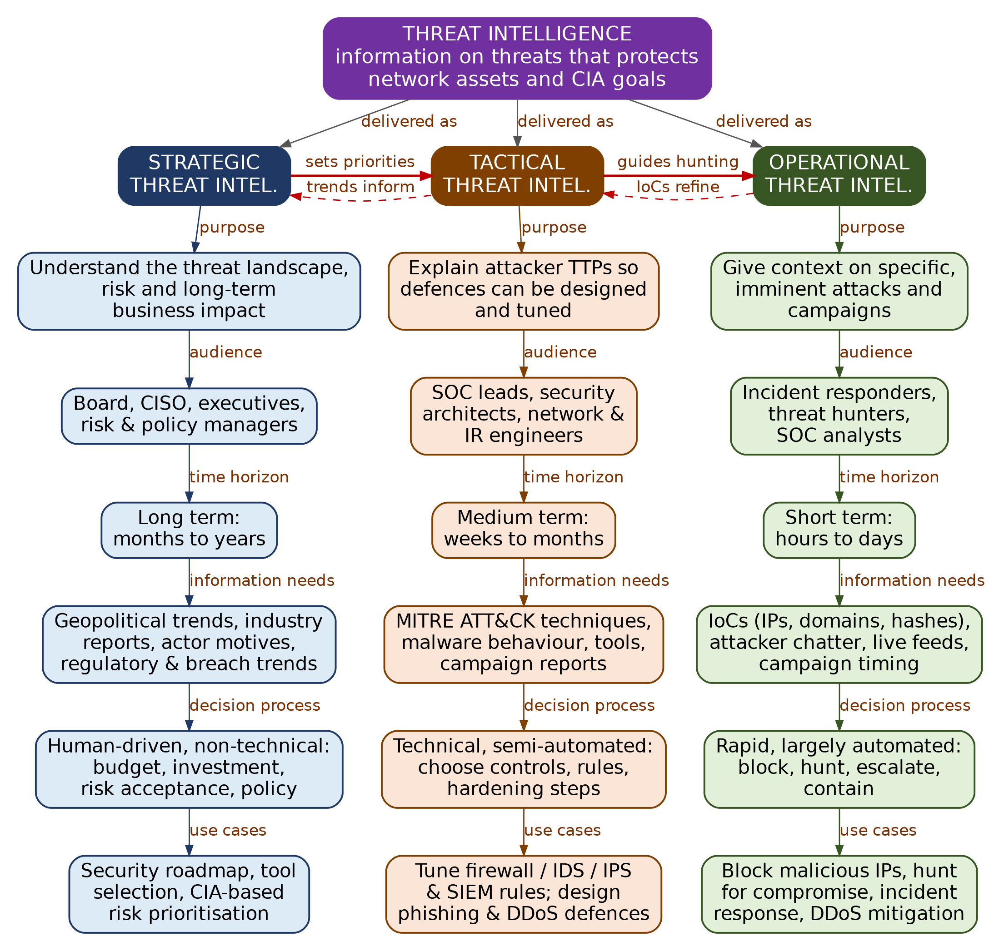
3. Explanation of the Relationships
Dimension | Strategic | Tactical | Operational
Purpose | Understand the threat landscape, risk and long-term business impact | Explain attacker TTPs so defences can be designed and tuned | Give context on specific, imminent attacks and campaigns
Target audience | Board, CISO, executives, risk and policy managers | SOC leads, security architects, network and IR engineers | Incident responders, threat hunters, SOC analysts
Time horizon | Long term (months to years) | Medium term (weeks to months) | Short term (hours to days)
Information requirements | Geopolitical trends, industry and breach reports, actor motives, regulation | Attack techniques (MITRE ATT&CK), malware behaviour, tools, campaign reports | IoCs (IPs, domains, hashes), attacker chatter, live feeds, campaign timing
Decision-making | Human-driven, non-technical: budget, investment, risk acceptance, policy | Technical, semi-automated: choose controls, rules and hardening steps | Rapid, largely automated: block, hunt, escalate, contain
Network-security use cases | Security roadmap, tool selection, CIA-based risk prioritisation | Tune firewall/IDS/IPS/SIEM rules; design phishing and DDoS defences | Block malicious IPs, hunt for compromise, incident response, DDoS mitigation
4. Analysis
How the three types complement one another. Strategic intelligence decides what matters (for example, ransomware against the sector is the top risk), so it sets priorities for tactical work. Tactical intelligence explains how that threat operates and what controls counter it, which tells operational teams what to hunt for. Operational intelligence supplies live indicators and incident outcomes, which refine tactical knowledge and report back to strategic planners. This two-way flow is shown by the red solid and dashed arrows on the map.
Evaluation of each type on its own. Strategic intelligence is valuable for justified investment but is too abstract to stop an attack in progress. Tactical intelligence gives durable defensive value but needs skilled staff to apply it. Operational intelligence gives the fastest protection but is perishable: indicators such as IPs and domains become stale within days.
Judgement. No single type is sufficient. Relying only on operational feeds leaves an organisation reactive; relying only on strategy leaves it without technical defence. A balanced programme uses all three, with effort weighted to the organisation's size and maturity: small teams usually start with operational and tactical feeds, while larger organisations add strategic analysis for risk governance.
Illustration (ransomware campaign): Strategic – the board approves backup and segmentation funding after a sector-wide ransomware trend report. Tactical – the SOC tunes email filtering and endpoint rules for the group's known phishing and lateral-movement techniques. Operational – responders block the campaign's command-and-control IPs and hunt for matching file hashes today.
5. Conclusion
Strategic, tactical and operational threat intelligence differ in purpose, audience, time horizon, data needs and decision style, yet they form one connected system. Strategy sets direction, tactics shape defences, and operations deliver immediate protection while feeding evidence back upward. Evaluated together, they give an organisation both foresight and rapid response.

